CIVE 340 Fluid Mechanics and Laboratory
Experiment 4: Force on Plate
Hagop Harfoushian
5/7/2013

Introduction
This experiment aims to determine the force acting on a plate through experimental work based on the momentum equation and compare the findings with those obtained by directly measuring the force acting on the plate.

Equipment
The following equipments were used to carry out this experiment:
- Hydraulic bench
- Jet impact apparatus (nozzle diameter 7 mm)
- Three plates: Flat (0 º), 120º and 180º (horizontal).
- Stop watch

Procedure
To carry out this experiment we followed the following procedure:
- Mount the plate on the jet impact apparatus.
- Install the flat plate.
- Level the apparatus by adjusting the legs to get the bubble centered in the spirit level.
- Adjust the level gauge to point to the datum on the weight pan.
- Place a nominal mass (say 100 g) on the weight pan.
- Open the supply valve and adjust the flow until the weight pan is back to its initial level.
- Take readings of volume and time to find the flow rate and note the mass on the weight pan.
- Add additional mass on the weight pan and repeat steps 3 to 6 for two additional settings.
- Repeat the experiment for the 120º and 180º plates.
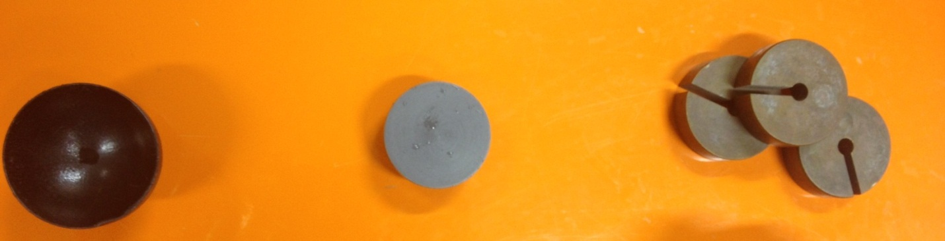
Masses,
100g each
Flat plate
180⁰ plate

Detailed Derivation of Equations 1, 2 & 3
Assumptions made in the derivation:
- Z1 and Z2 are very close to each other, and therefore, there difference is considered to be null. This yields (using Bernoulli) that V1=V2.
- Neglect the weight of water.

Momentum equation: -F_{x} = ρQ(V₂.cos(α) – V₁.cos(β)) where α is the angle of projection of V2 leaving the plate, and β is the angle of projection of V1 entering the plate. β is always = 0.

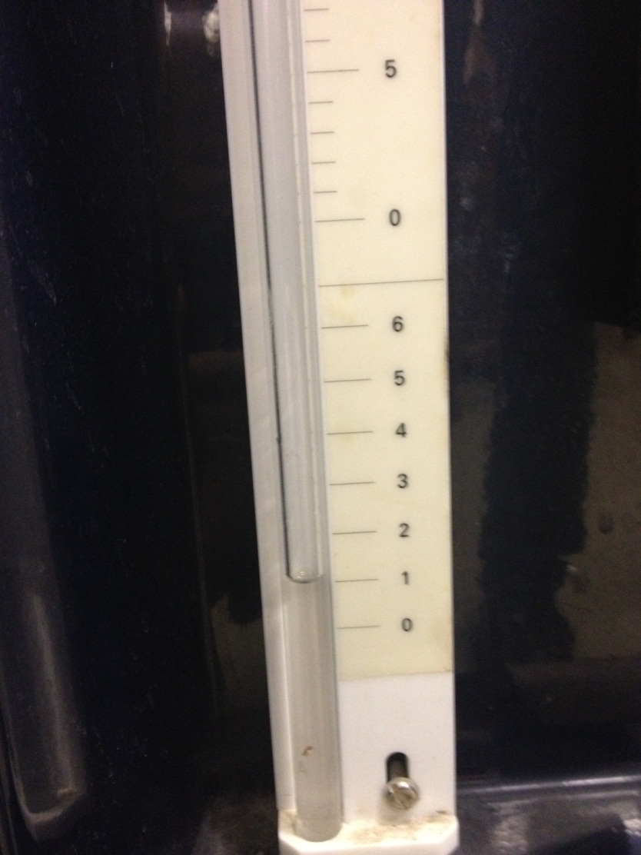
Flat Plate
α= 90 therefore,
-F_{x} = ρQ(V_{x2}.cos(90) – V_{x1})
V=Q/A, and V1=V2 (explained above)
F_{x}= (ρQ²/A) [EQN 1]

120º Plate
α= 60 therefore,
-F_{x} = ρQ( -V_{x2}.cos(60) – V_{x1})
F_{x}= ρQ(V₁ + V₂.cos(60))
V=Q/A, and V1=V2 (explained above)
F_{x}= ρQV₁ (1+cos (60)) = 3/2(ρQV₁)
F_{x}= (3/2) (ρQ²/A) [EQN 2]

180º Plate
α= 0 therefore,
-F_{x}= ρQ( -V_{x2}.cos(0) – V_{x1})
F_{x}= ρQ(V₁ + V₂.cos(0))
V=Q/A, and V1=V2 (explained above)
F_{X} = ρQV₁ (1+cos (0)) = 2(ρQV₁)
F_{X} = 2(ρQ²/A) [EQN 3]

Collected Data

Flat Plate
Mass (g) | Volume (m³) | Time (s) | Flow rate (m³/s)
100 | 0.005 | 25.2 | 0.000198
200 | 0.005 | 18.48 | 0.000271
300 | 0.005 | 17.95 | 0.000279

120º Plate
Mass (g) | Volume (m³) | Time (s) | Flow rate (m³/s)
100 | 0.005 | 31.31 | 0.00016
200 | 0.005 | 23.14 | 0.000216
300 | 0.005 | 22.35 | 0.000224

180º Plate
Mass (g) | Volume (m³) | Time (s) | Flow rate (m³/s)
100 | 0.005 | 33.82 | 0.000148
200 | 0.005 | 24.55 | 0.000204
300 | 0.005 | 19.48 | 0.000257

Calculations:
In order to calculate the experimental force, we only need to substitute the density, flow rate, and the area in the equations found above. On the other hand, the theoretical force on the plate must be equal to the weight placed on the apparatus F=Mg.
These results are summed up in the table below.
Flat Plate  Using Eq. 1 | Experimental |  | Theoretical |  | Percent error
100g | 1.022946606 |  | 0.981 |  | 4.275902744
200g | 1.908326233 |  | 1.962 |  | -2.735666017
300g | 2.022657947 |  | 2.943 |  | -31.27224101
120 º  Using Eq. 2 |  | Experimental | Theoretical | Percent error
100g |  | 0.997804051 | 0.981 | 1.712951211
200g |  | 1.818497884 | 1.962 | -7.314073209
300g |  | 1.955695941 | 2.943 | -33.54753854
180 º  Using Eq. 3 |  | Experimental | Theoretical | Percent error
100g |  | 1.138328122 | 0.981 | 16.03752517
200g |  | 2.162740281 | 1.962 | 10.23141088
300g |  | 3.432497906 | 2.943 | 16.63261657

Conclusion
There are slight errors in the experiment which may result from one of the following reasons:
- Human errors (errors in recording time for example)
- Neglecting the weight of water (which leads to the negative percent error)
- Experimental and apparatus errors (when using a mass of 300g, the jet was not strong enough to lift the weight to its initial position, and we used the maximum that the apparatus can handle. This is why we see a large percent error for the mass 300g.

